Profit and Loss Worksheet Year 8 Name: ___________________

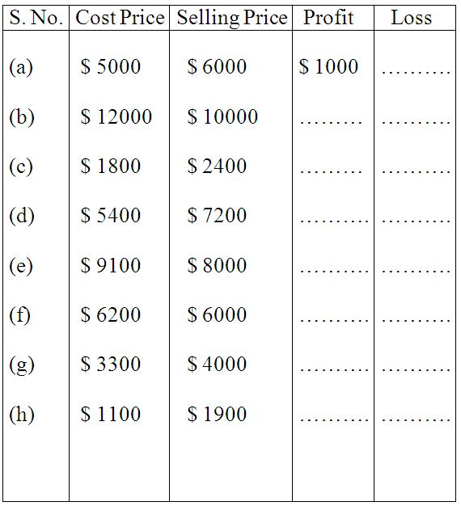

Word Problems on Profit and Loss.
- A TV was bought for $ 18,950 and old at a loss of $ 4780. Find the selling price.

- A second-hand car was sold for $ 190000, at a loss of $ 85. Find the CP of the car.

- Monica sold her genset for $ 20000 at a profit of $ 1737. Find the CP of genset.

- Sam bought a music system for $ 6375.00 and spent $ 75.00 on its transportation He sold it for $ 6400.00. Find his profit or loss percent.

- Nick bought pens at $ 120 a dozen. He sold it for $ 15 each. What is his profit percent?

- Radhi bought a study table for $ 9000. She sold it at a profit of 20%. How much profit did she make? What is the selling price?

- Find the selling price if the cost price is $ 1200 and loss percent is 25.

- Robert bought 20 refills and sold them at $ 4 each. If it had cost $ 50 for the refills, what was his profit or loss percent?

- Mr. Summers buys pencils at $ 250 per hundred and sells each at $ 1.75. Find his loss or profit.

